**‘AccessBank DBA Internship Program’**

**Project 20: Sending a report in the Excel file**

At 2:03 PM, you received an email from one of the employees of the Sales department. Email included an excel file which contained details about customers of your company based on their **Account Numbers**.

You are asked to response the email with prepared report which is also in excel file.

Summary of your task:

You need to have AdventureWorks2014 database and Excel software for this project.

You have to send a report in the excel file which has Account Number, StoreID, TerritoryID and ModifiedDate for the provided Account Numbers. You can find these columns from Sales.Customer table.

**Firstly I checked Sales.Customer table and its columns before starting the task:**

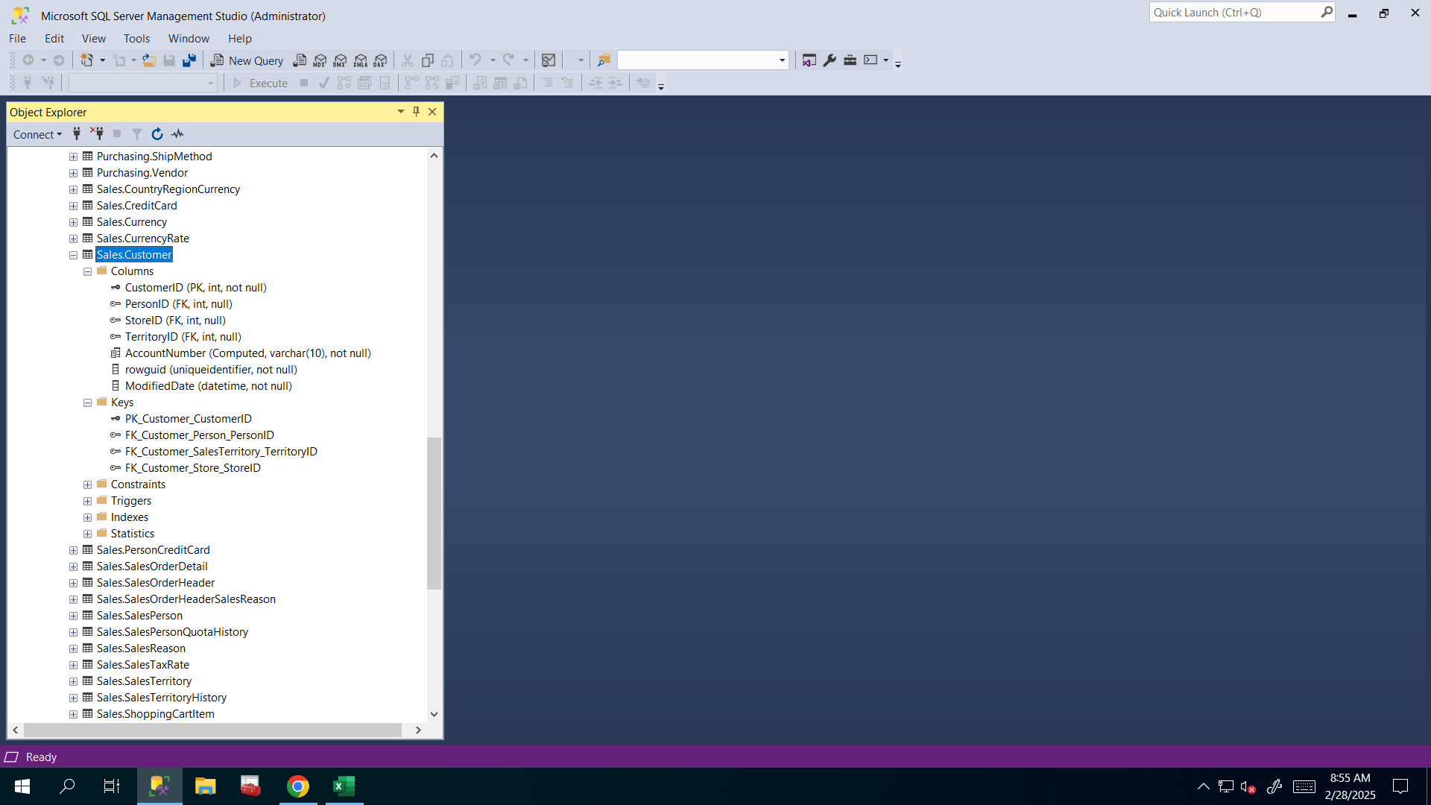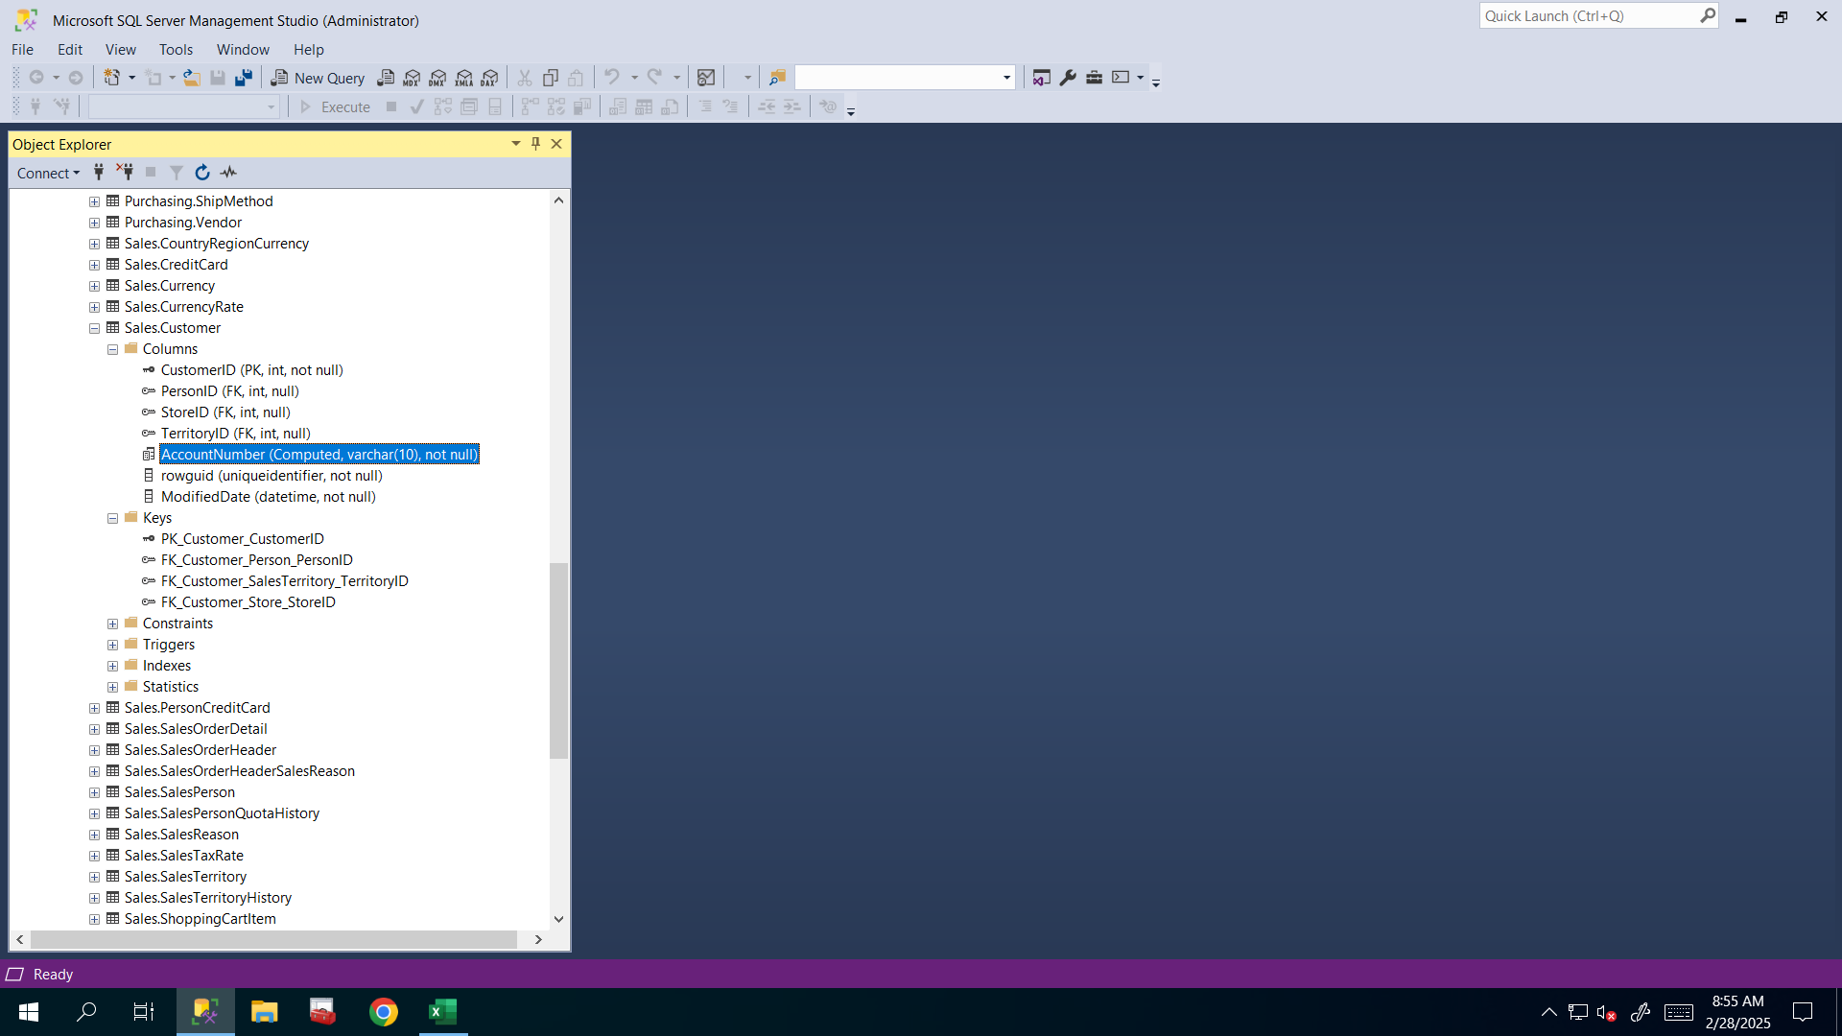

**I used that formula =”’”&A2&”’,” and by using bold plus icon that’s appearing whenever I hover cell’s bottom right corner I filled other rows too and by using Ctrl+Shift+(down arrow) combination I selected all rows that I needed and by using Ctrl+C combination I copied all of them to clipboard.**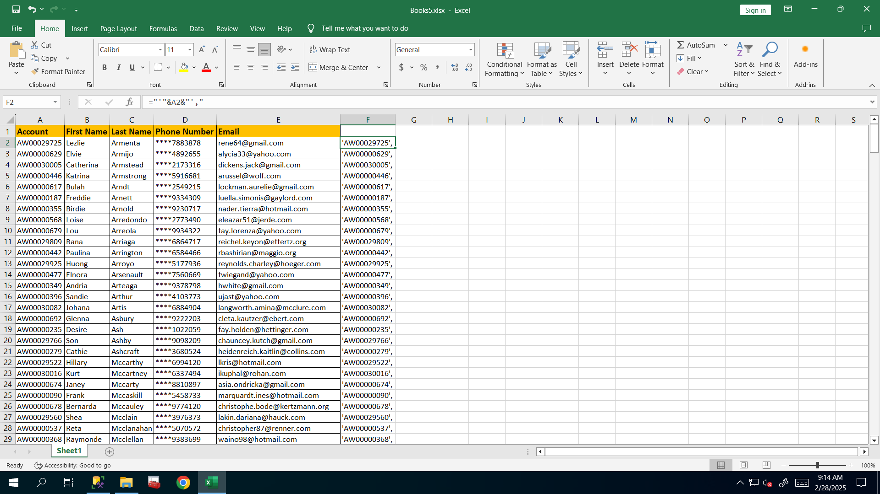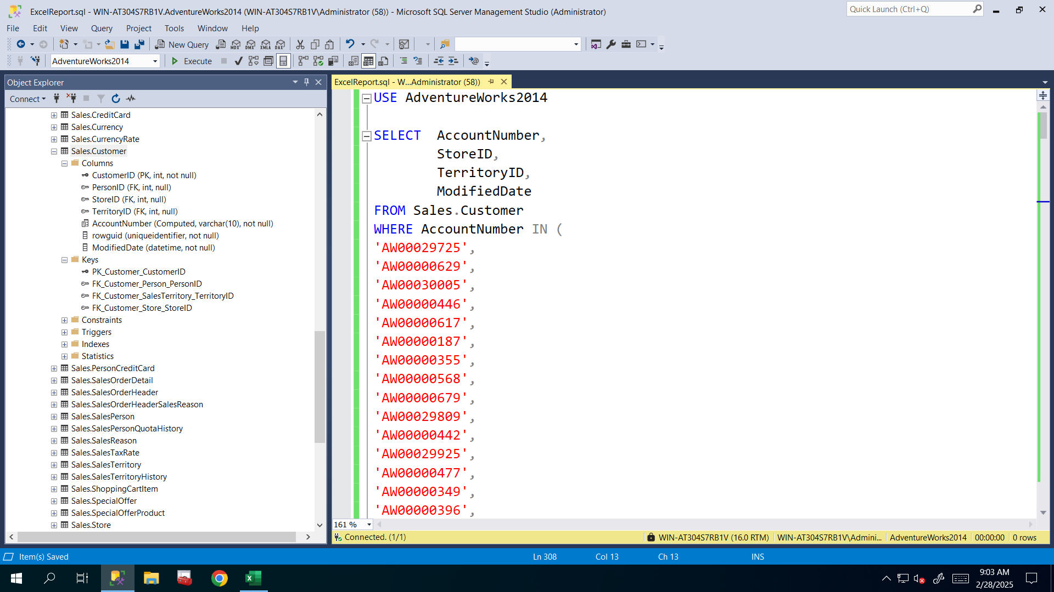

**Here I pasted it and completed my T-SQL script to retrieve needed data. I can save it as .csv file but I want to make that task more interesting so I will export it as .xlsx file by using export wizard.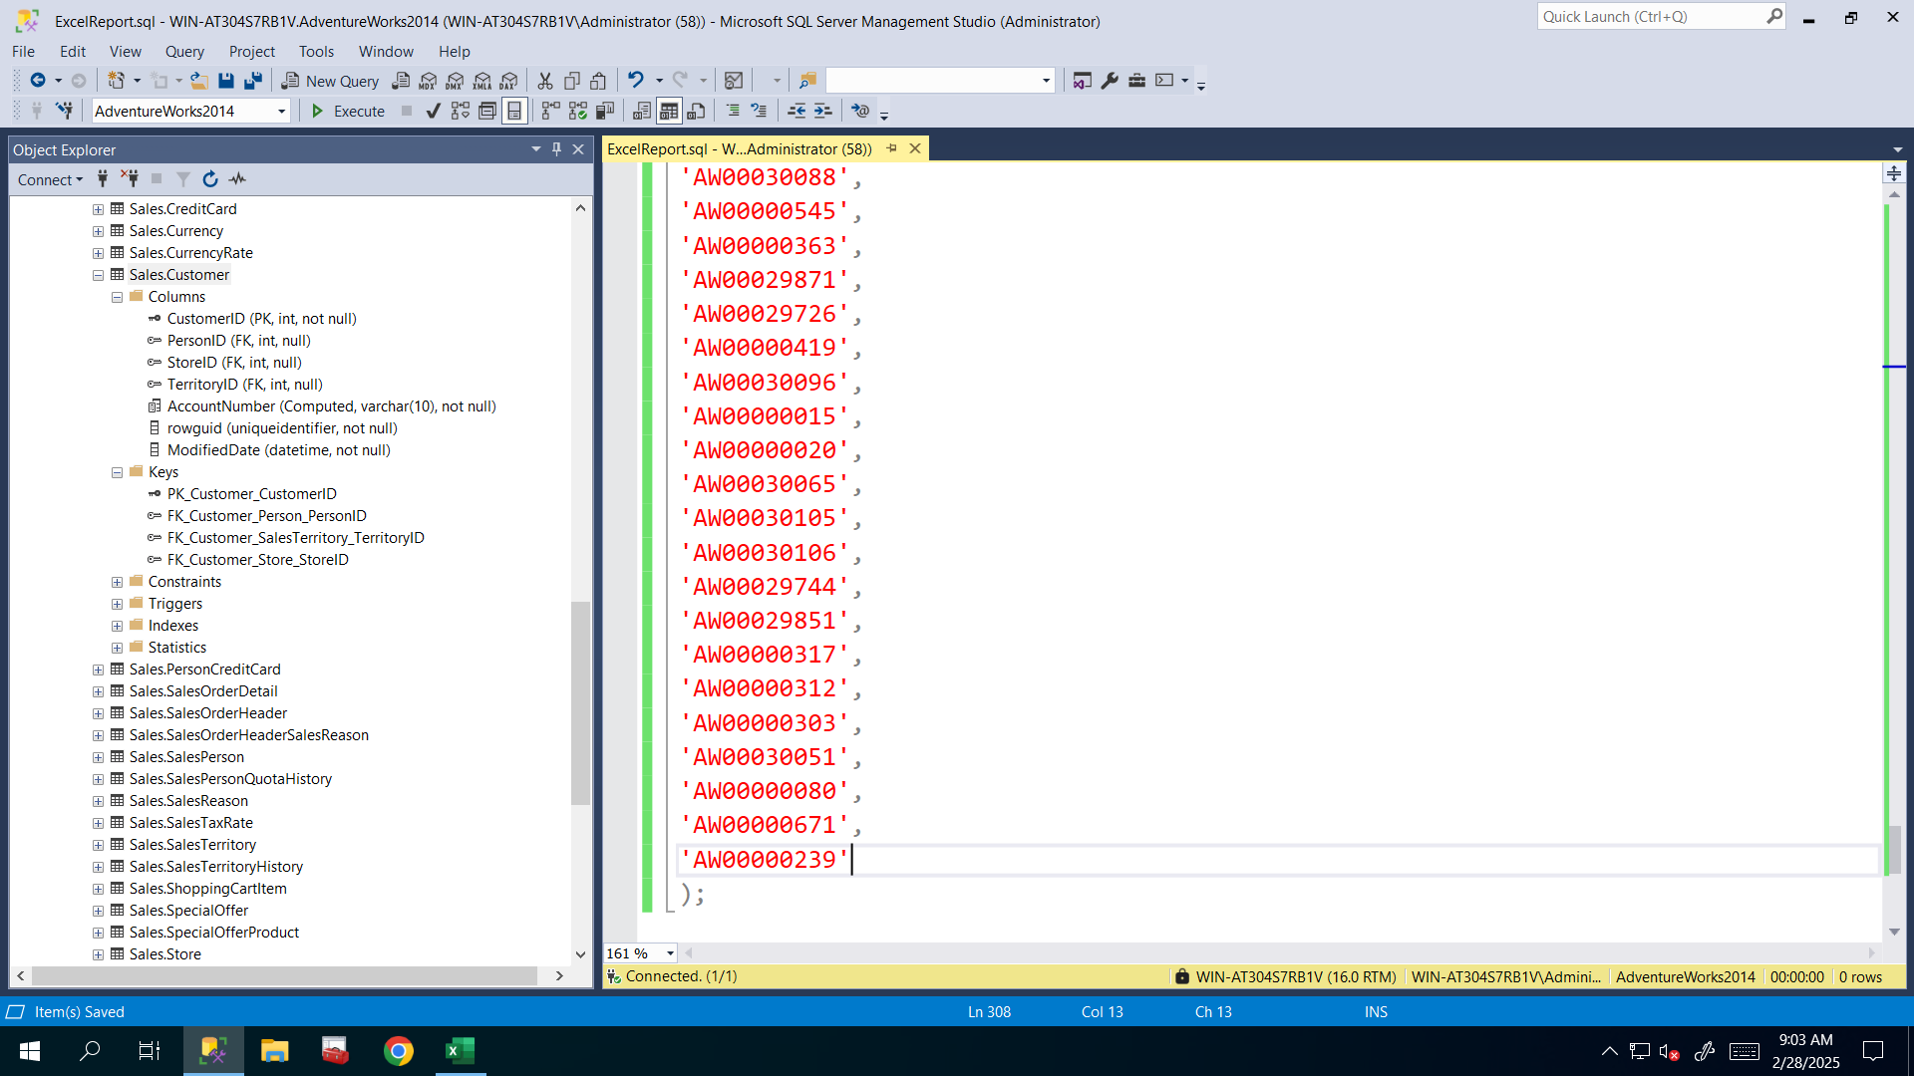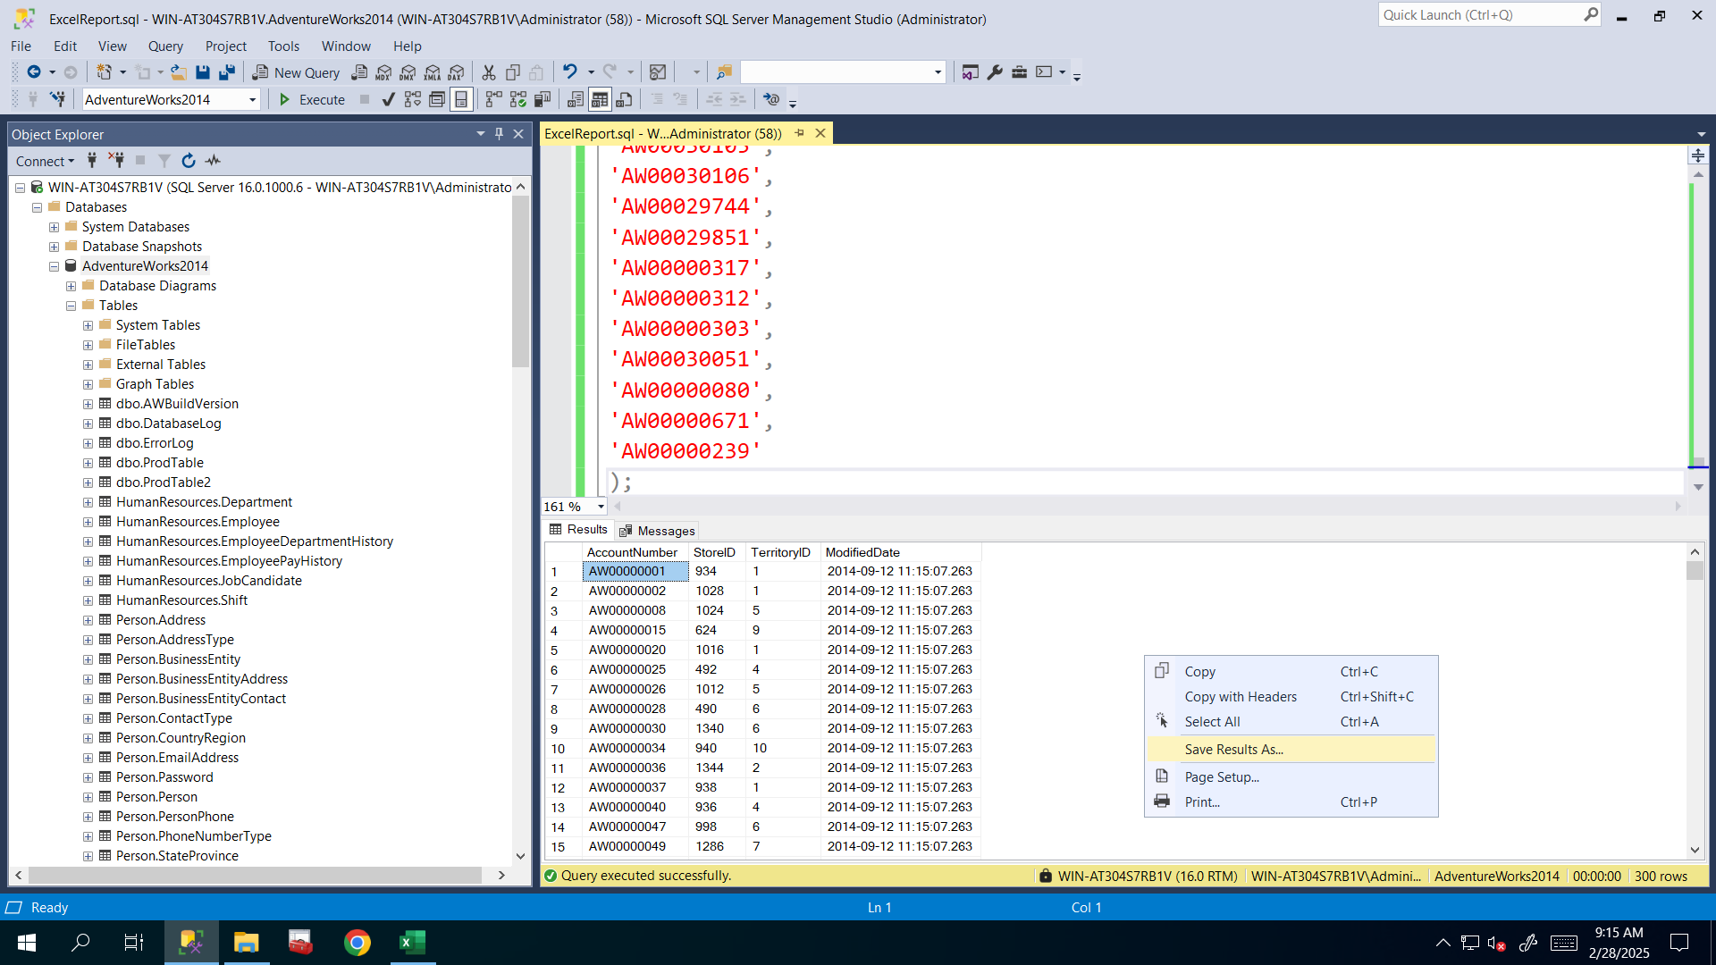I right clicked on AdventureWorks2014 database and here from Tasks list I clicked Export data… option to open Export Data wizard.**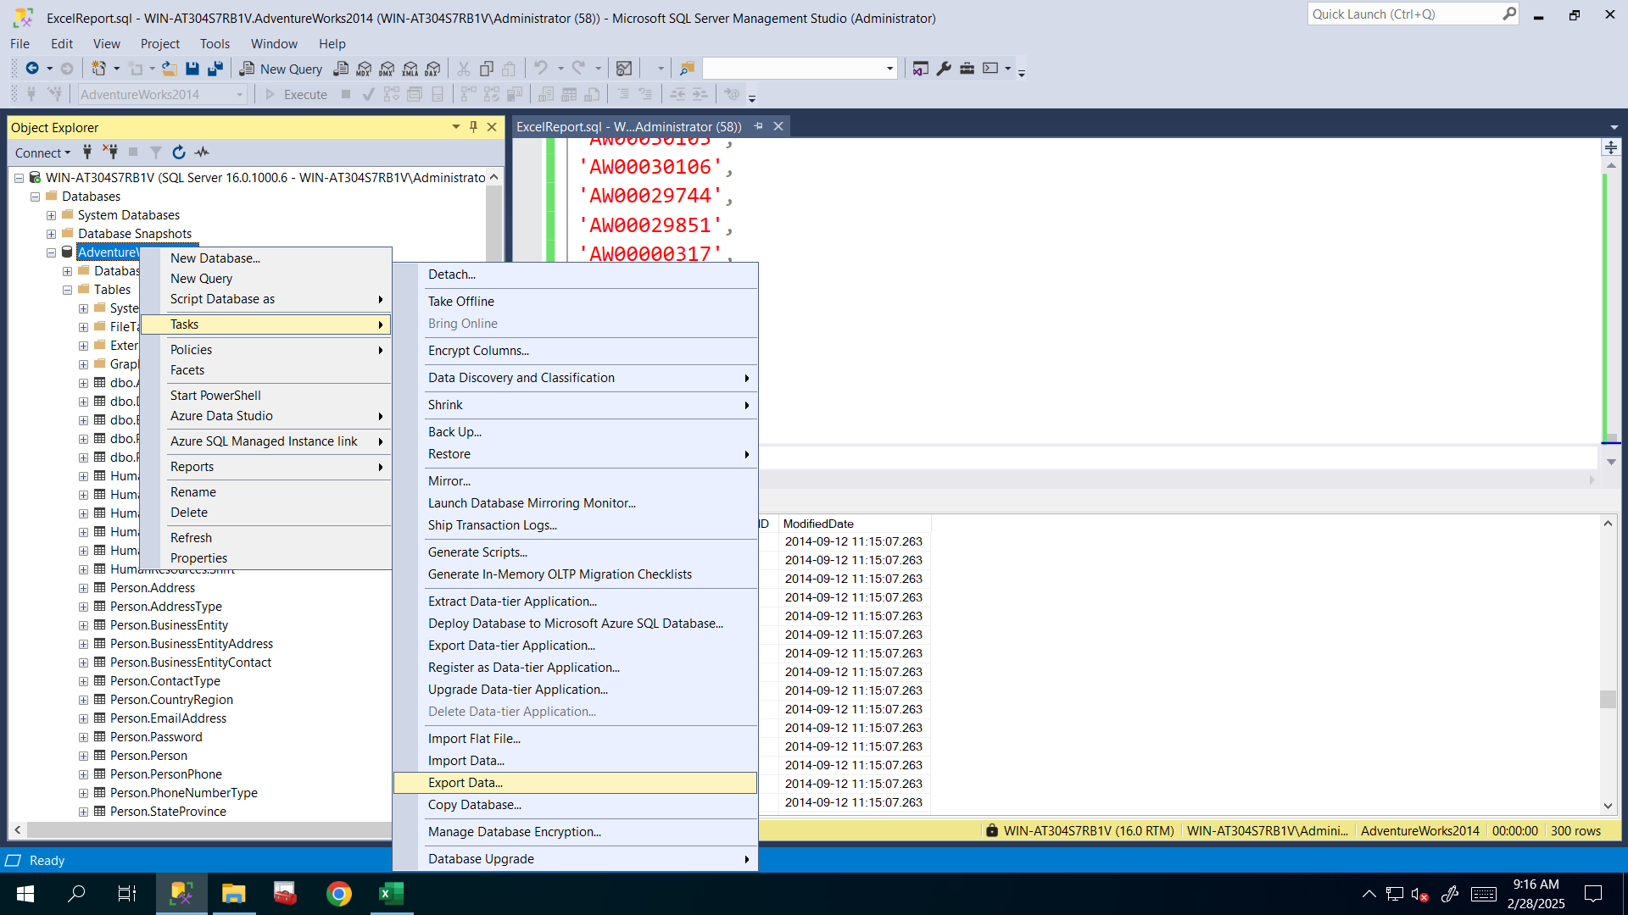

**I selected AdventureWorks2014 as data Source.**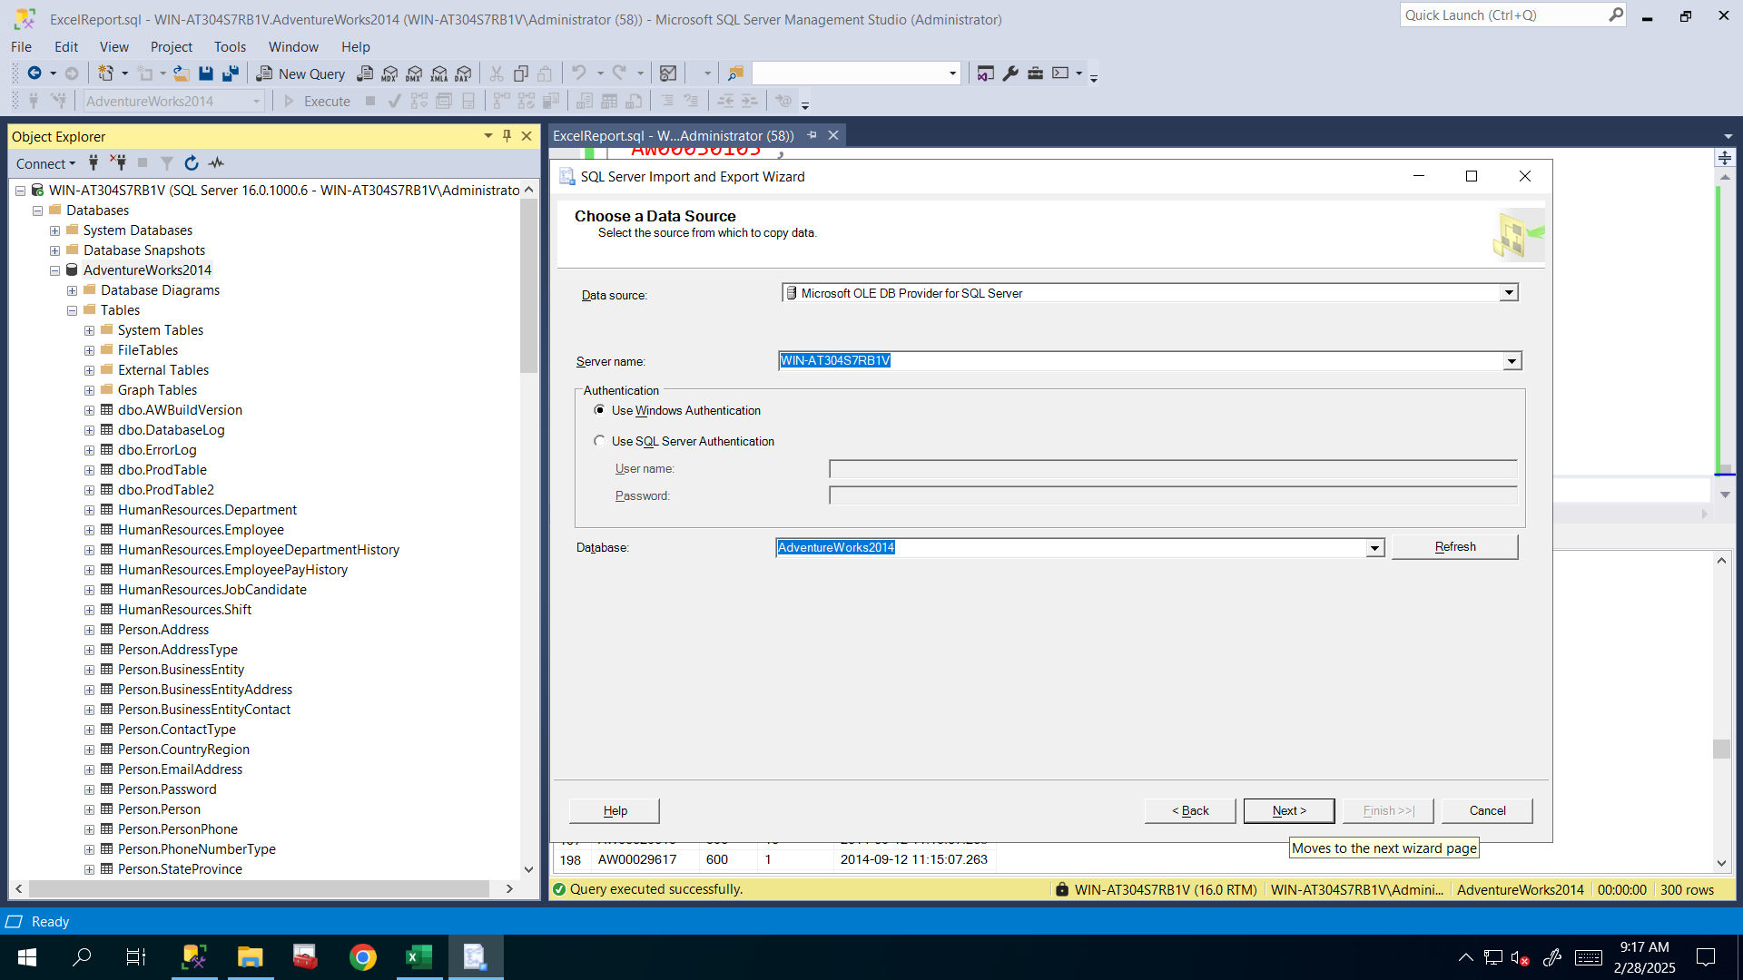

**For the destination, I browsed for my newly created Report.xlsx file to export data into it.**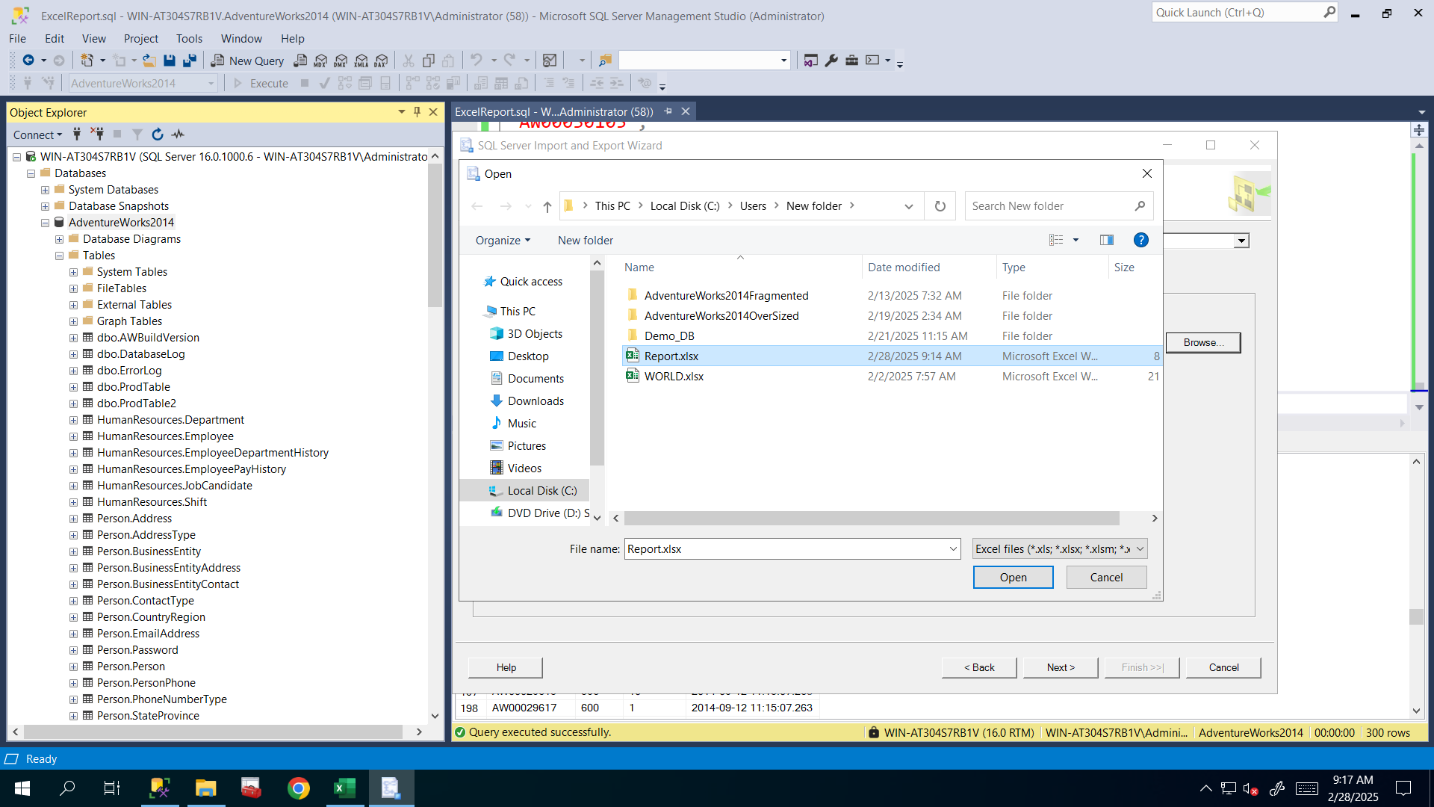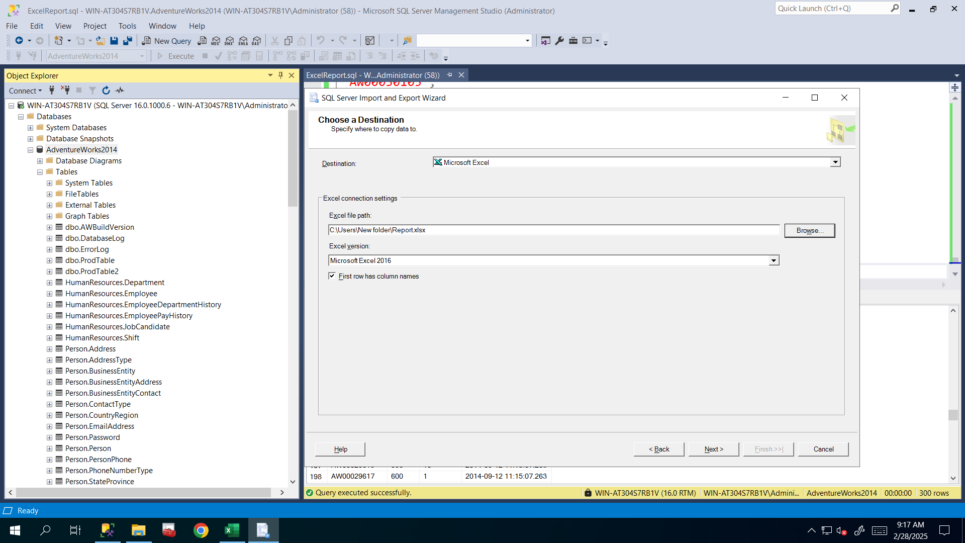

**I will need some of the rows of that table so I will write the query to export only needed rows and needed columns not all of the table. That’s why I selected second option here.**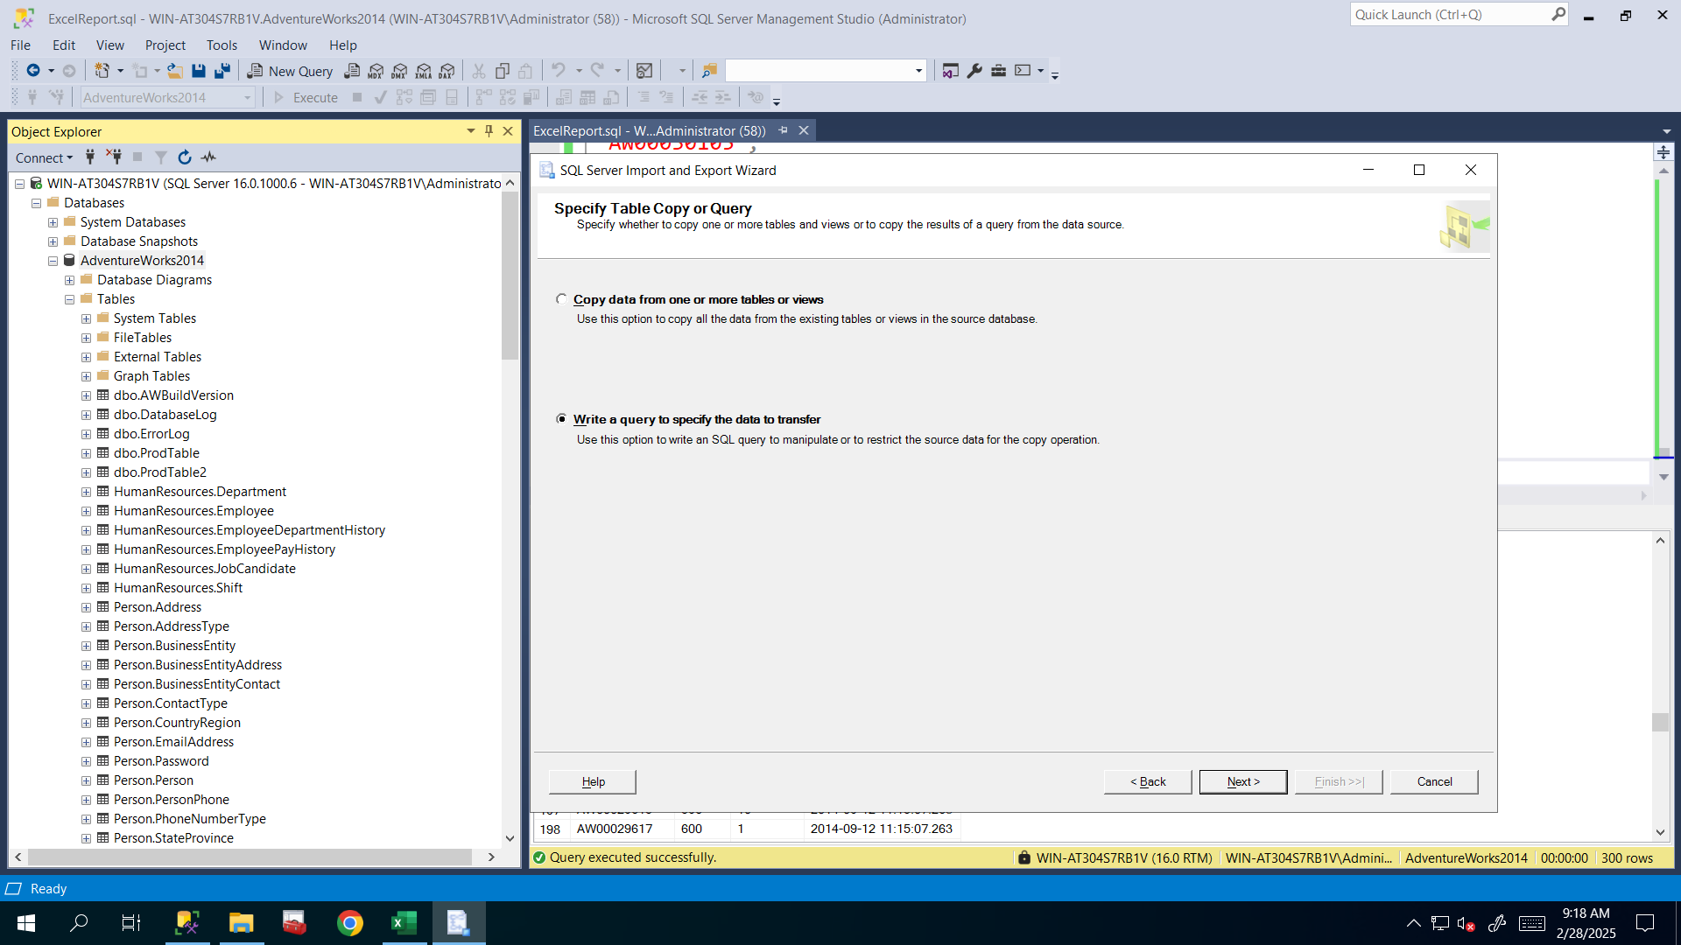

**I copied previous T-SQL script , and pasted into the wizard, after that I parsed it to see whether SQL statement is valid or not, and it’s valid. 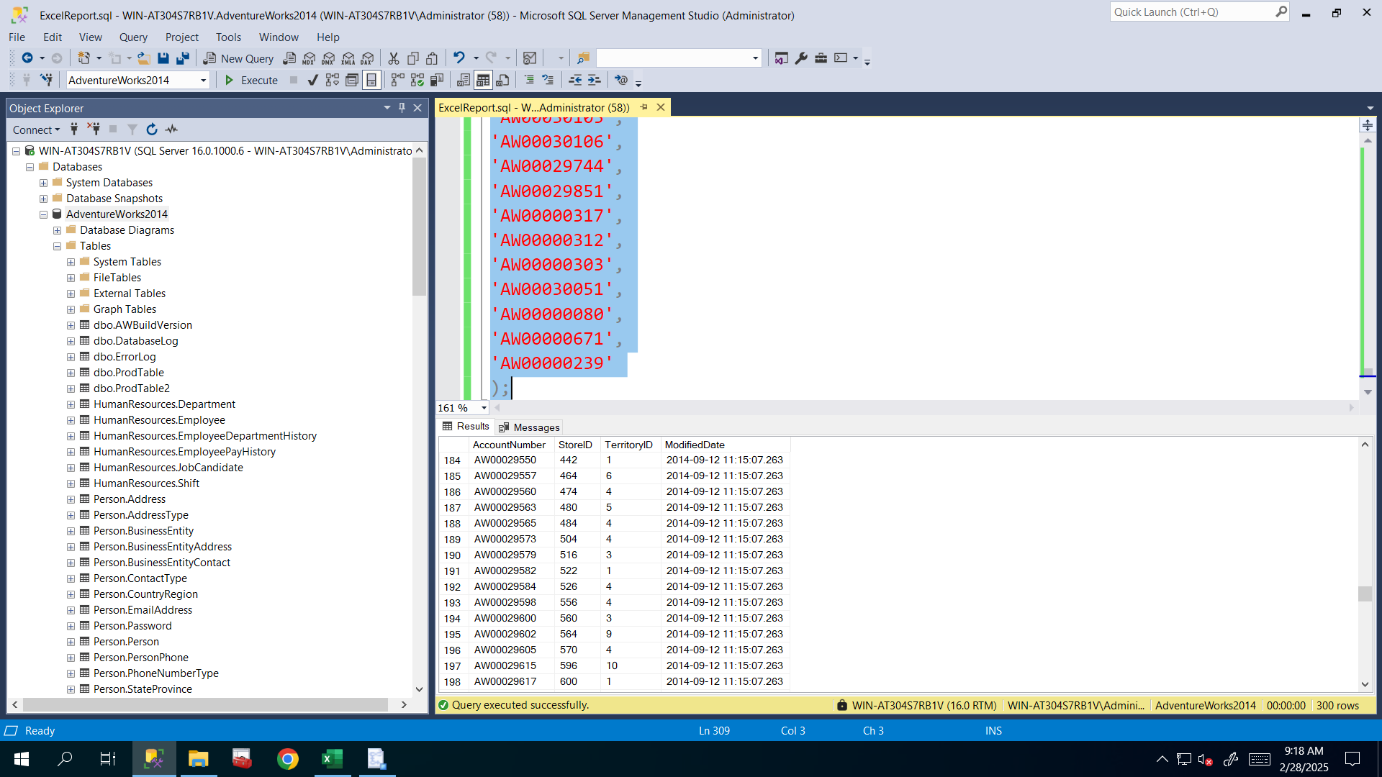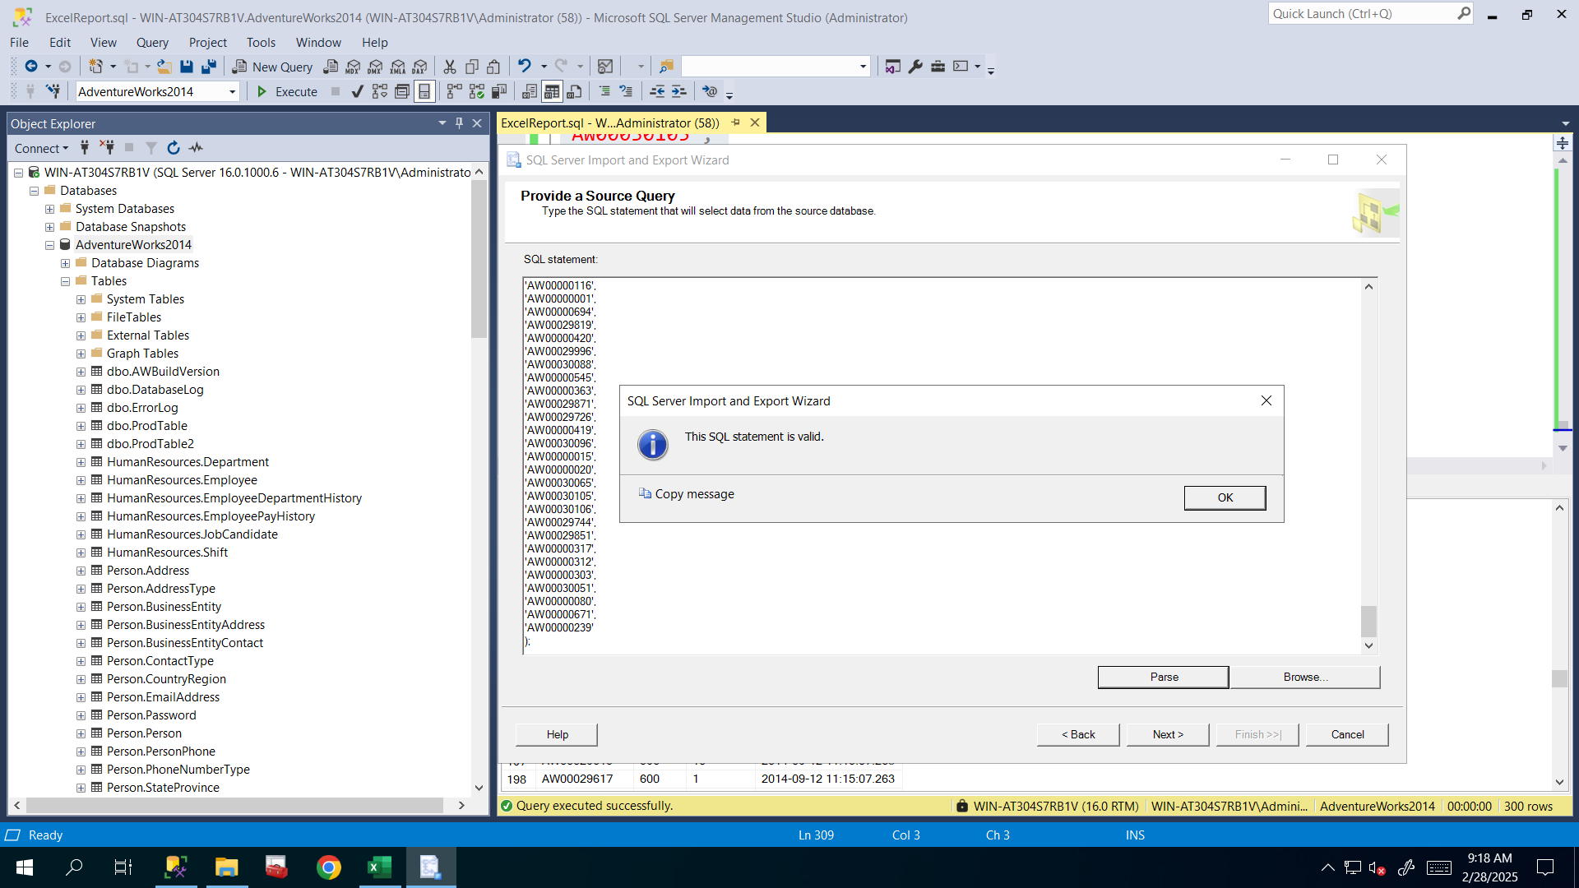I renamed it Report as destination sheet and editted mappings for AccountNumber from Long Text to VarChar(10) and clicked Next**.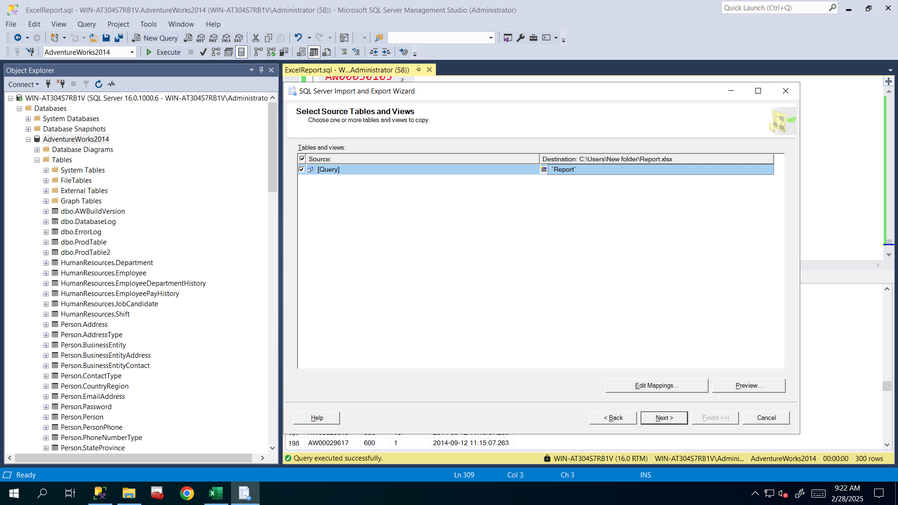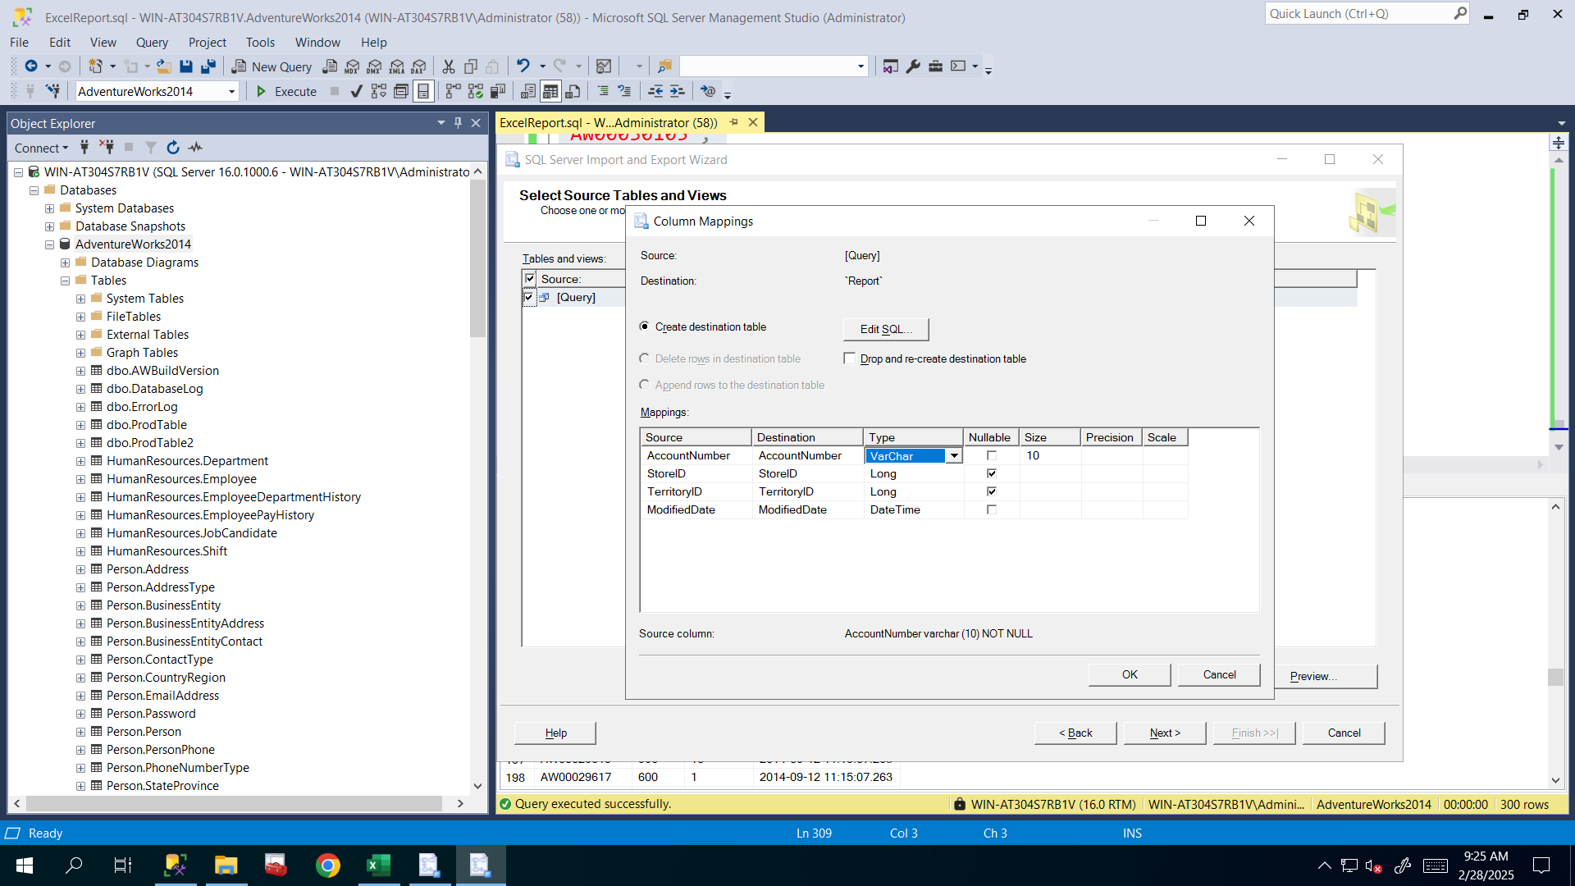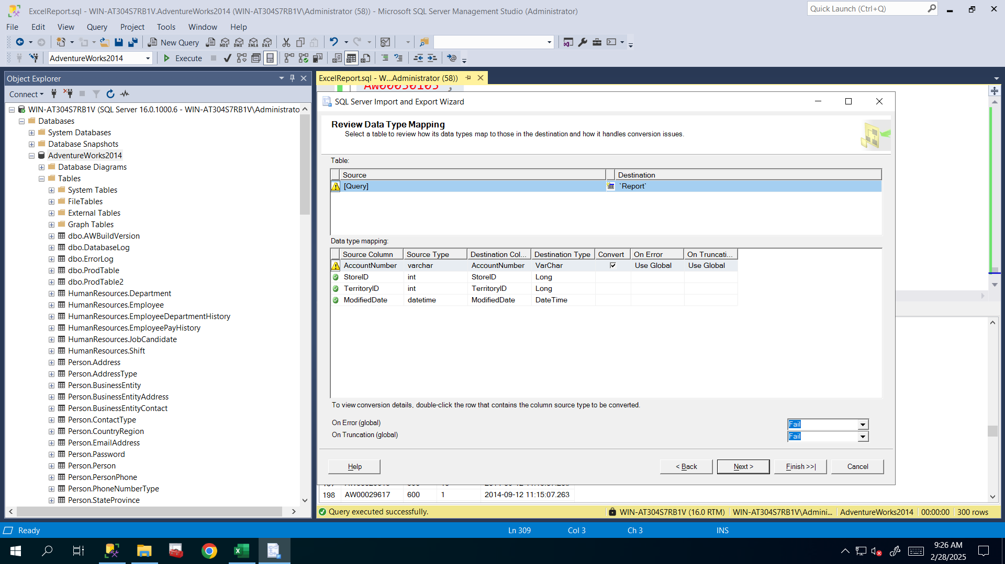

**After seeing that everything is okay I clicked Run immediately.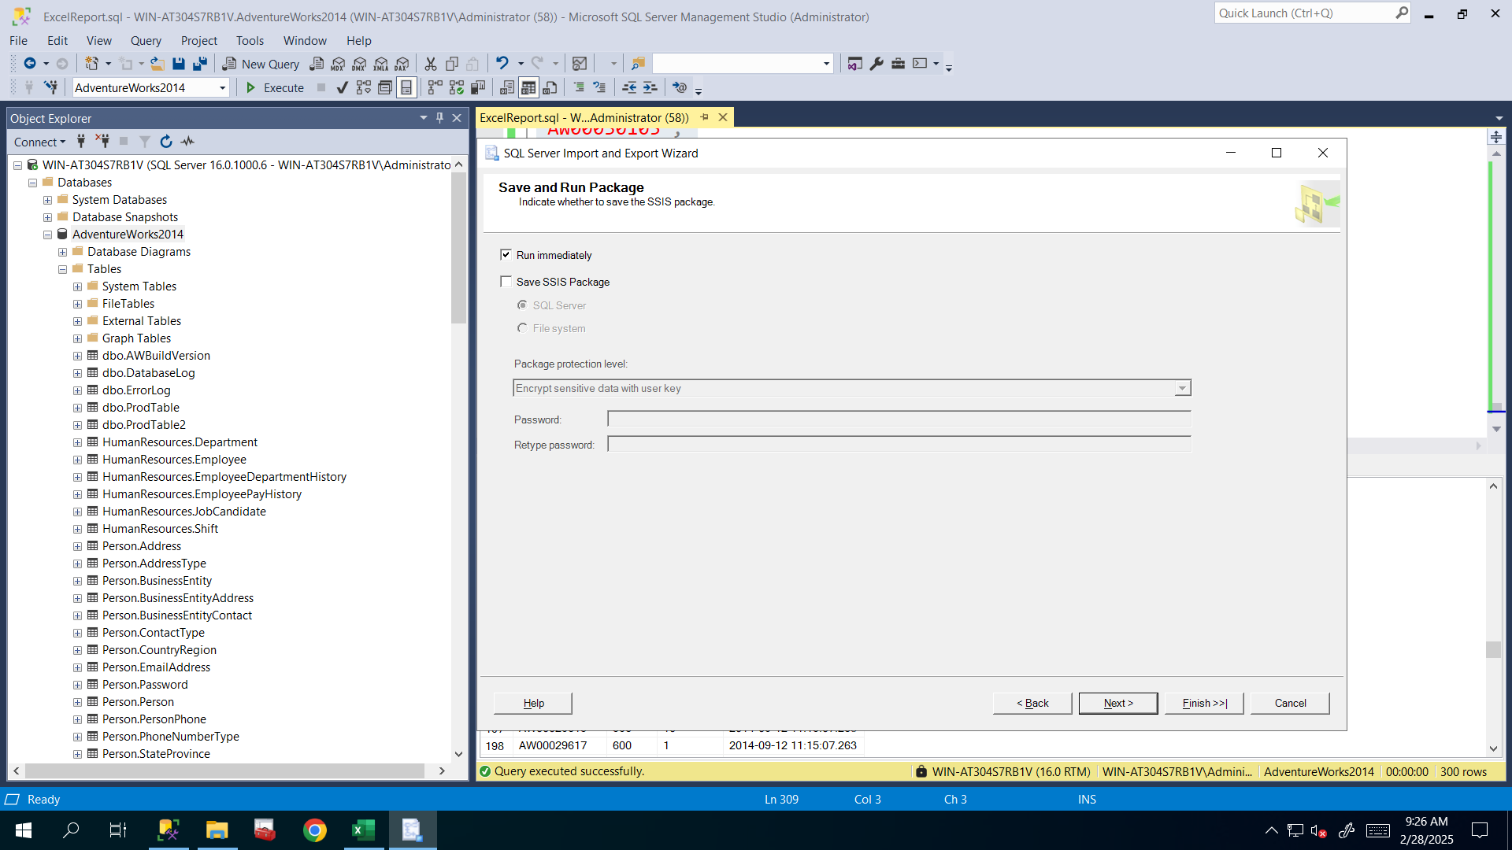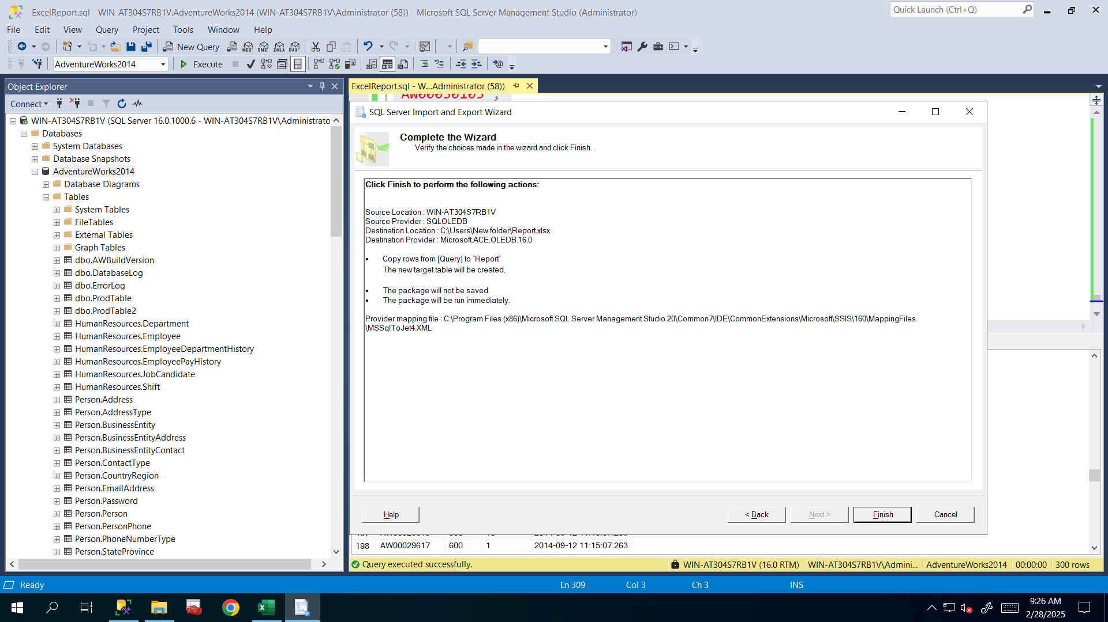Here I make sure that all of these actions are correct then clicked Finish and saw that it’s succesfully exported all needed rows and columns of that table.**

**I also checked the Report.xlsx file to see everything’s correct before sending that report in office or to you.**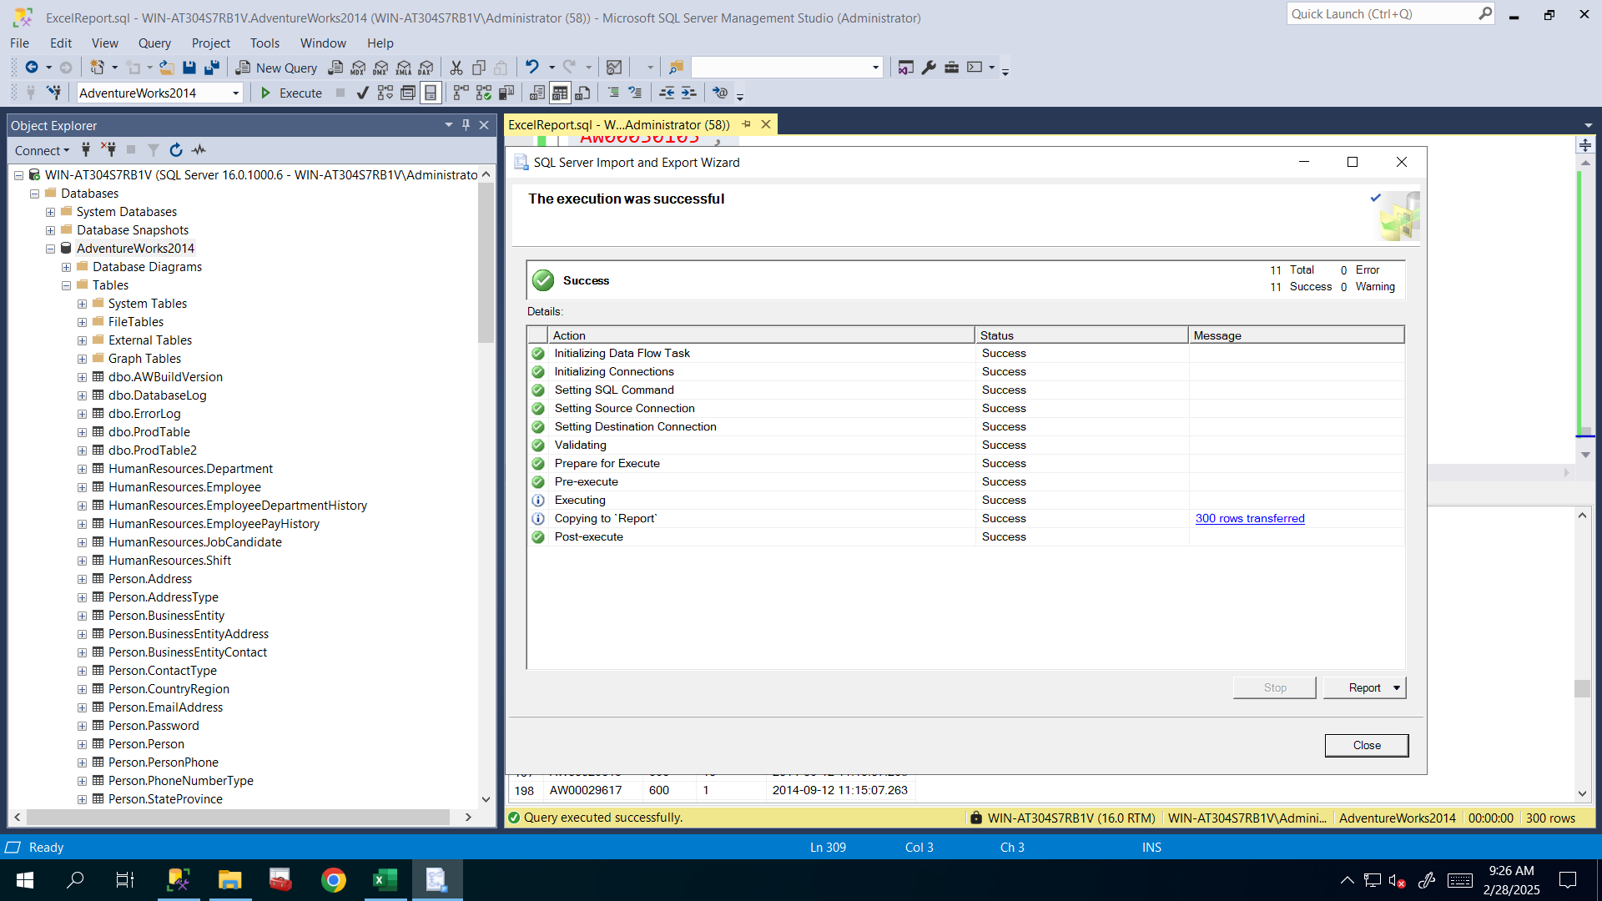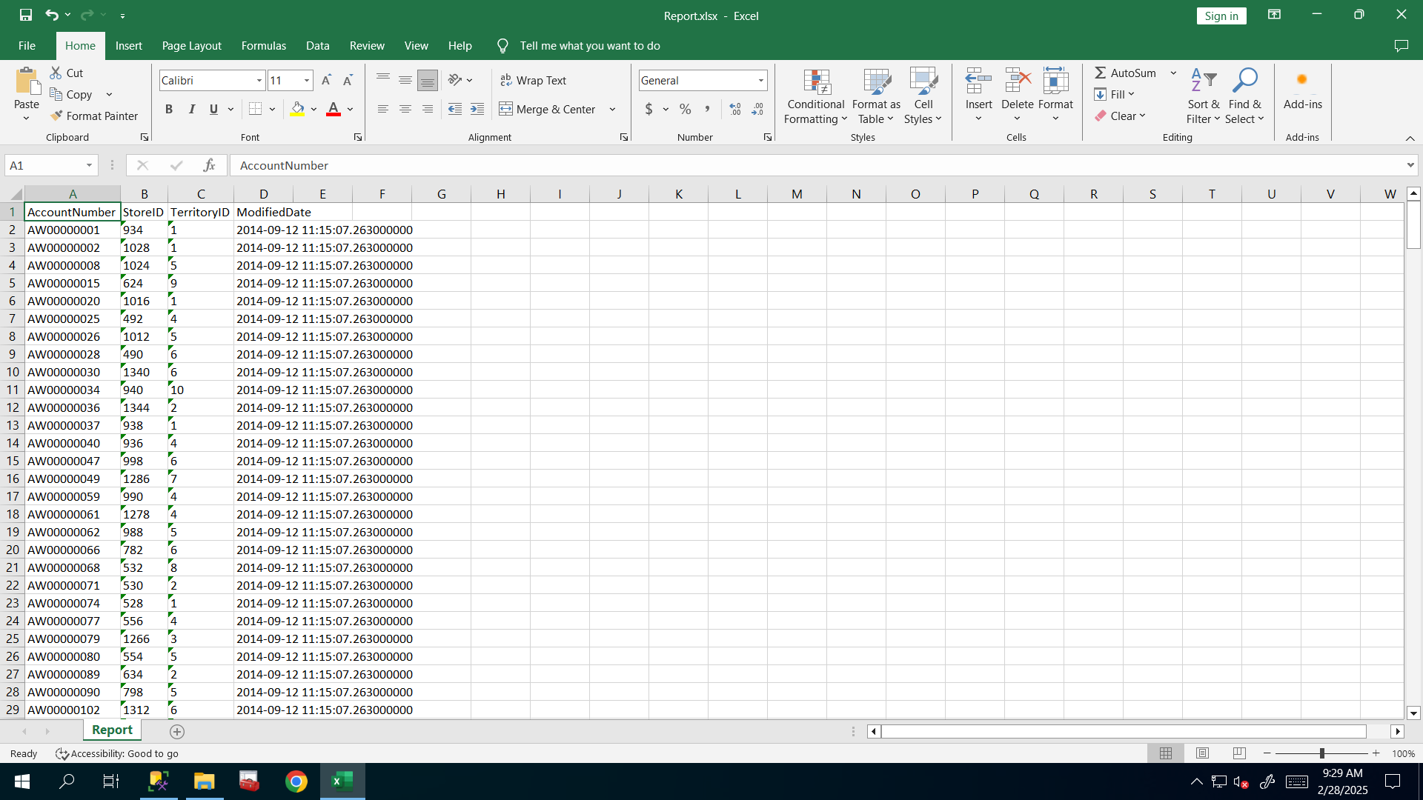

Hint:

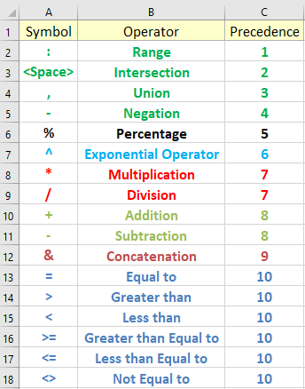

& means concatenation, like when you concatenate strings in the programming:

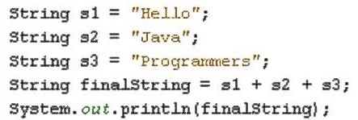

For other symbols you must put them into double quotes in order to make them as strings, otherwise they will be treated as indicated in the above picture. Another example is: you want to convert the below

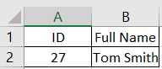 Into (27, ‘Tom Smith’) format

Formula for this format is: =“(“&A2&”,’”&B2&”’)”